# Software User’s Manual

## Installation Guide

### Setting up environment at server side

#### Hardware Requirement

|  |  |
| --- | --- |
| Hardware Specification | |
| Internet Connection | 100 Mbps |
| Server type | Shared Windows Hosting on Window Server |

#### Software Requirement

|  |  |
| --- | --- |
| Software | Application name/version |
| Operating System | Windows Server 2012 R2 |
| Visual Studio | 2013 or 2015 |
| Web Server | IIS 8.1 |
| Database | Microsoft SQL Server 2012 R2 |
| Control Panel | Plesk 11 |

### Deployment at server side

#### Prepare deployment package

* + Publish web application.
  + Step by step:

1. Click right into web package. Click to “Publish”

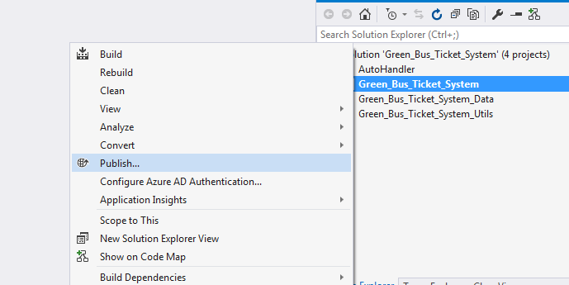

1. Publish web with steps bellows:

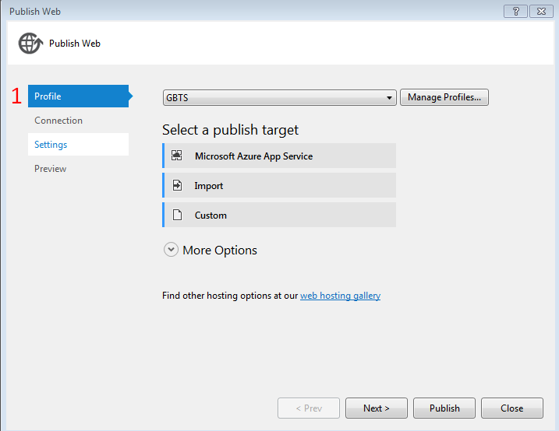

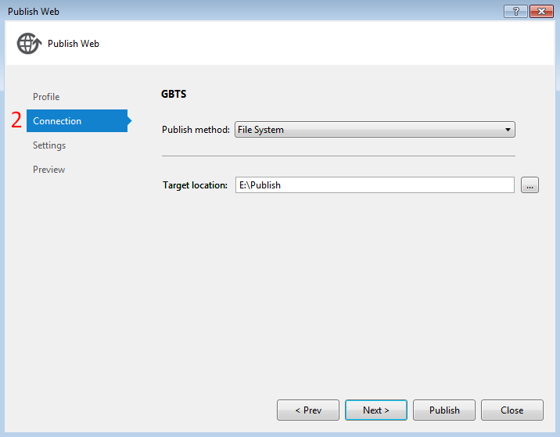

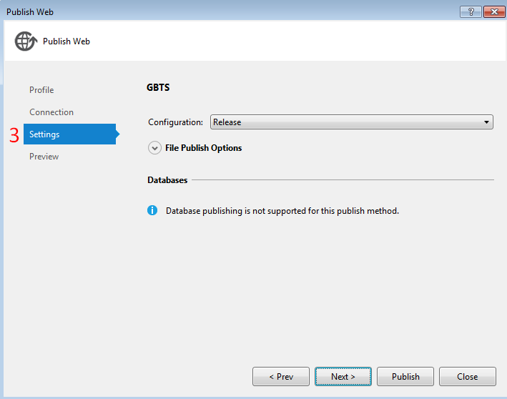

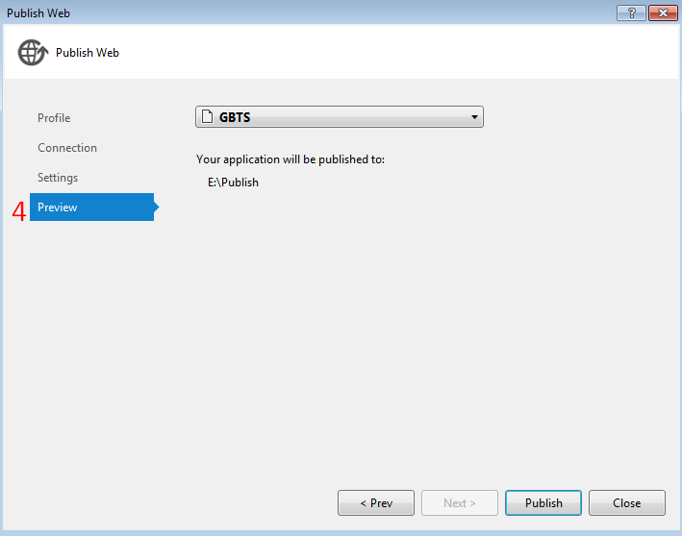

#### Deploy web application on server

* Step 1 : Go to Plesk Control Panel and login
* Step 2 : Click “File Manager” feature

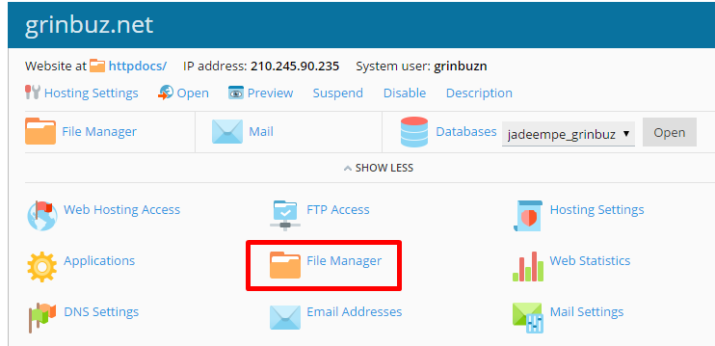

* Step 3: Upload all published files from Visual Studio to httpdocs folder

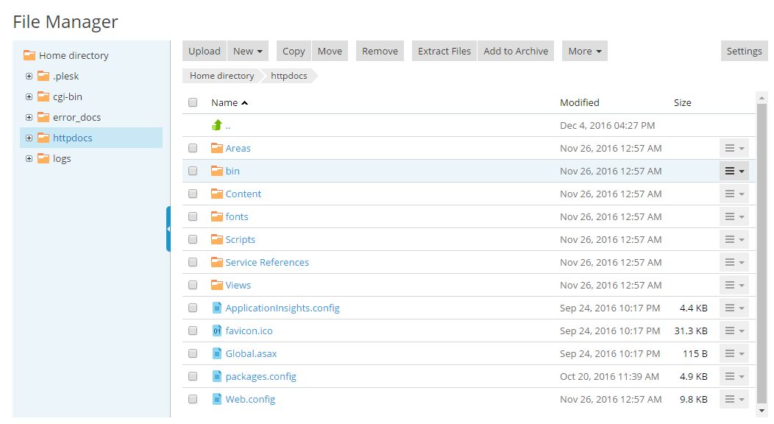

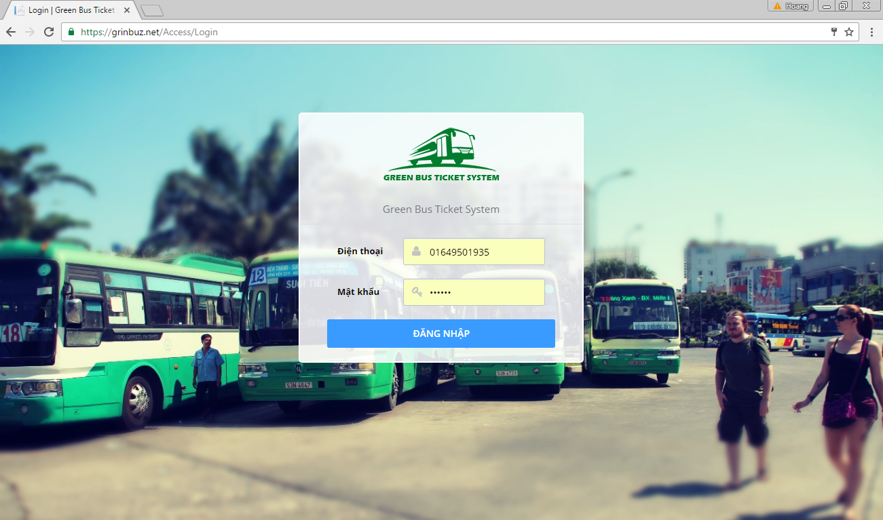

### Deployment at Client Side

* On mobile device, install one of the application from the GBTS package application apk from our attachment on the CD.

*For Bus Emulator:*

* + Install “GBTS Emulator”

*For Customer:*

* + Install “GBTS”

*For Staff:*

* + Install “Máy nạp tiền”
  + Install “CardPublisherStaff” for staff use
  + Install “GBTS Card Publisher” for web use

## User Guide

### Web application

* + 1. <Unauthorized user>Login

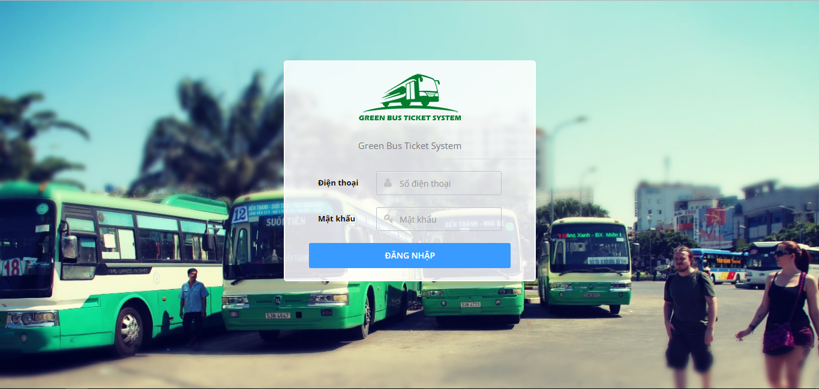

|  |  |
| --- | --- |
| Step | Description |
| 1 | Click “ĐĂNG NHẬP” button |

* + 1. <Passenger> Get NFC cards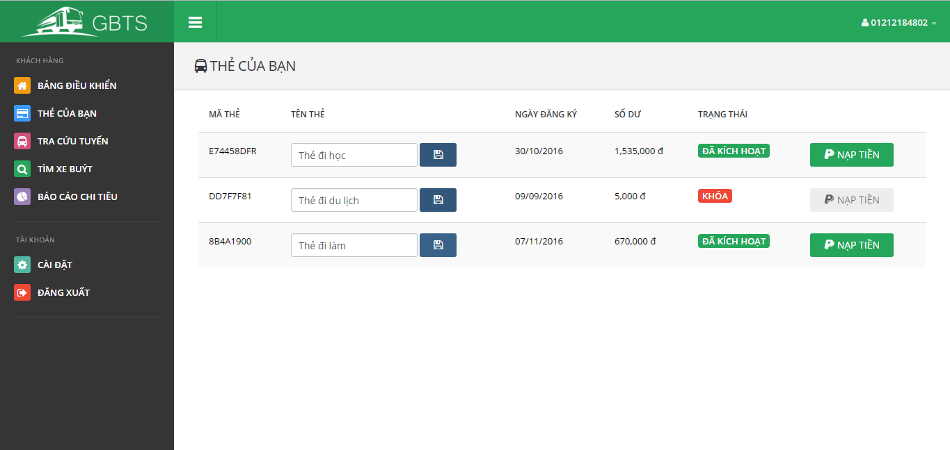

|  |  |
| --- | --- |
| **Step** | **Description** |
| **1** | Click “Thẻ của bạn” button |

* + 1. <Passenger> Edit card name

|  |  |
| --- | --- |
| Step | Description |
| 1 | Click “Thẻ của bạn” button |
| 2 | Input new card name |
| 3 | Click save button |

<Passenger> Add credit

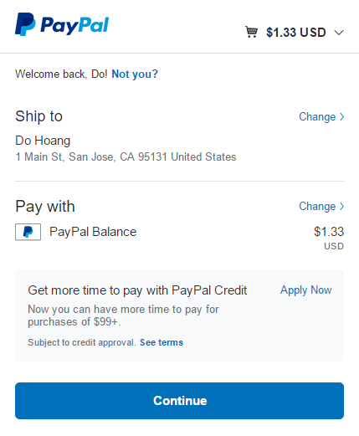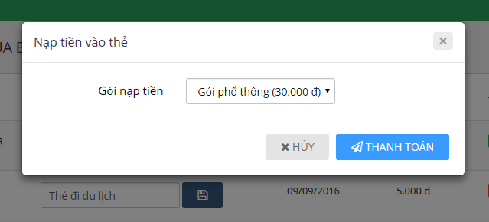

|  |  |
| --- | --- |
| Step | Description |
| 1 | Click “Thẻ của bạn” button |
| 2 | Click “Nạp tiền” button |
| 3 | Select a credit plan |
| 4 | Click “Thanh toán” button |
| 5 | Confirm the payment by clicking “Continue” |

* + 1. 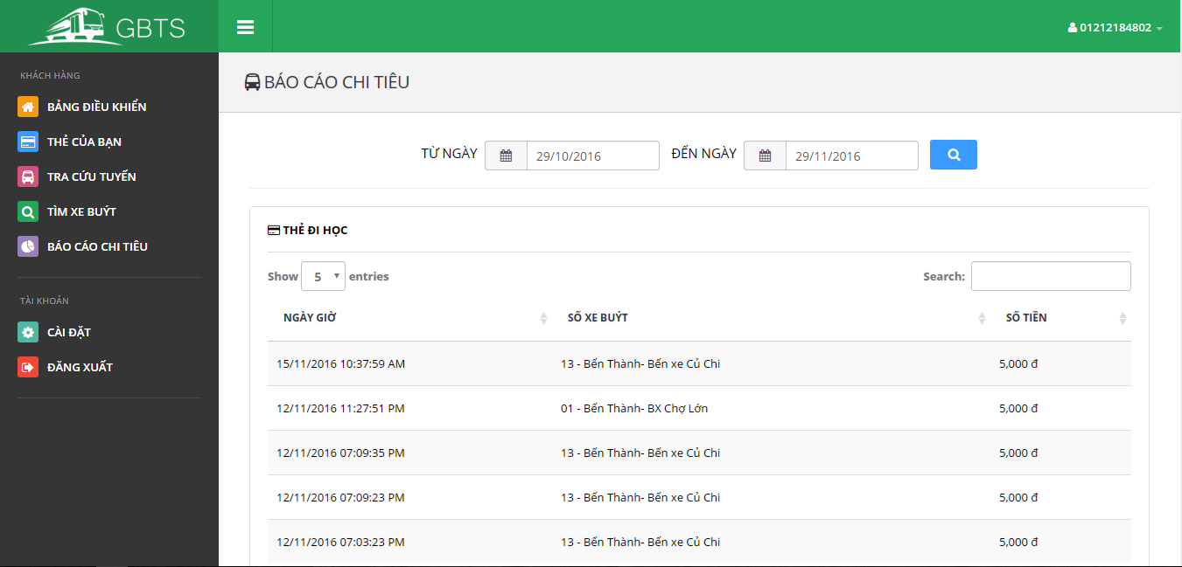<Passenger> Get outcome report

|  |  |
| --- | --- |
| Step | Description |
| 1 | Click “Báo cáo chi tiêu” button |

* + 1. <Passenger> Look up bus route

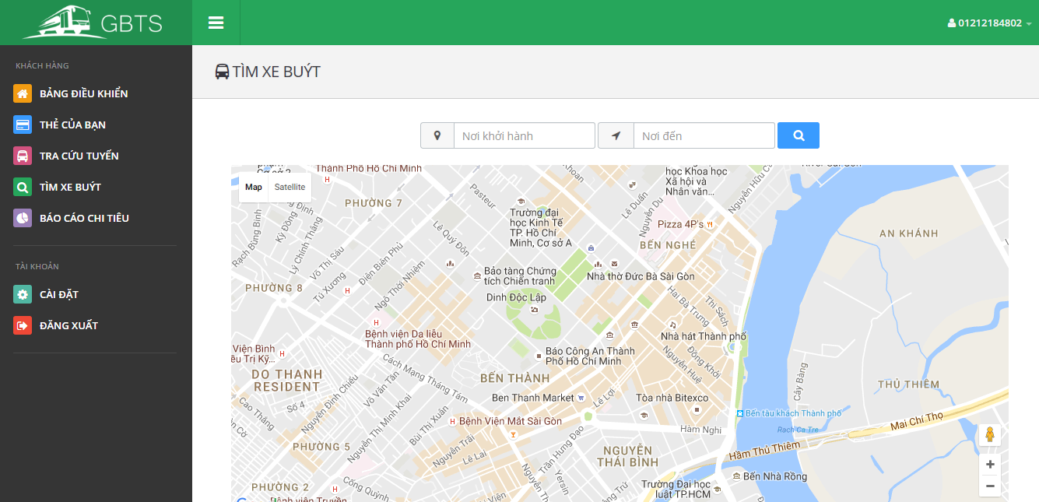

|  |  |
| --- | --- |
| Step | Description |
| 1 | Click “Tìm xe buýt” button |
| 2 | Input “Nơi khởi hành” and “Nơi đến” |
| 3 | Click search button |

* + 1. 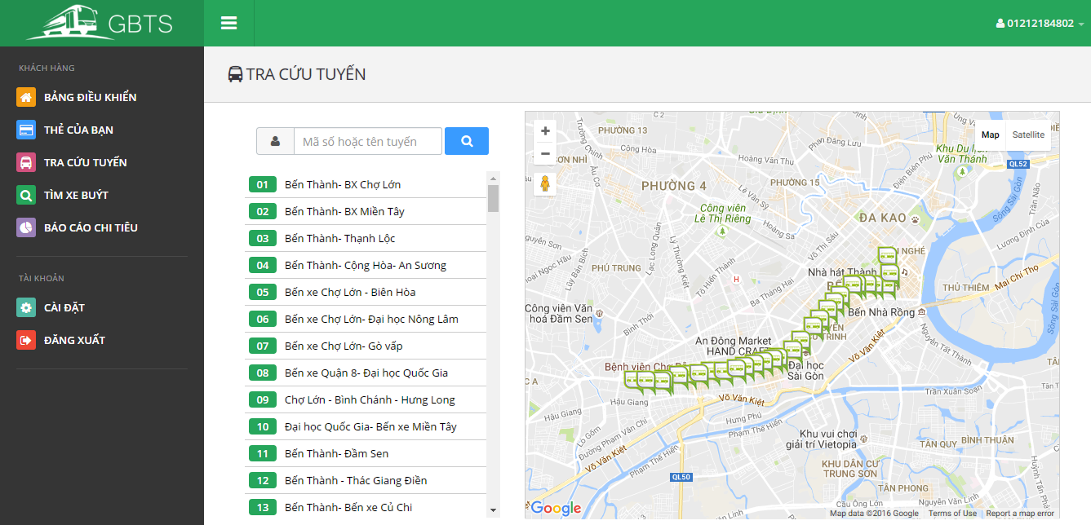<Passenger> Find bus

|  |  |
| --- | --- |
| Step | Description |
| 1 | Click “Tra cứu tuyến” button |
| 2 | Choose a bus route in a list or input bus route name or code into “Mã số tuyến hoặc tên tuyến” |

* + 1. <Administrator> Search account

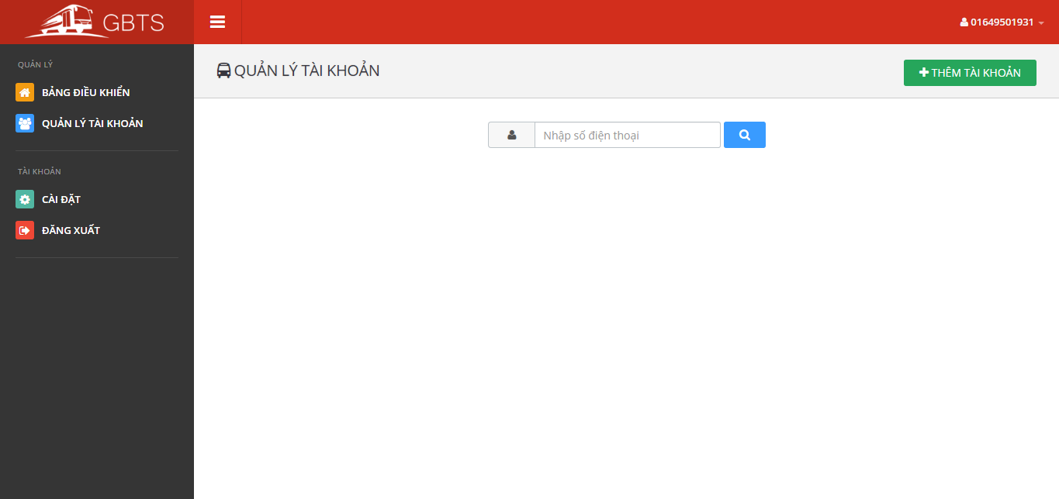

|  |  |
| --- | --- |
| Step | Description |
| 1 | Click “Quản lý tài khoản” button |
| 2 | Input a phone number |
| 3 | Click search button |

* + 1. <Administrator> Add account



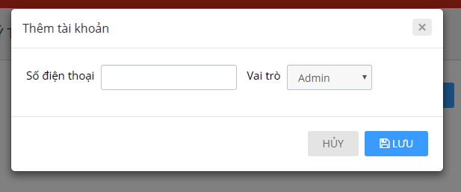

|  |  |
| --- | --- |
| Step | Description |
| 1 | Click “Quản lý tài khoản” button |
| 2 | Click Thêm tài khoản” button |
| 3 | Input phone number and select one of the roles |
| 4 | Click “Lưu” button |

* + 1. <Administrator> Activate/Deactivate account

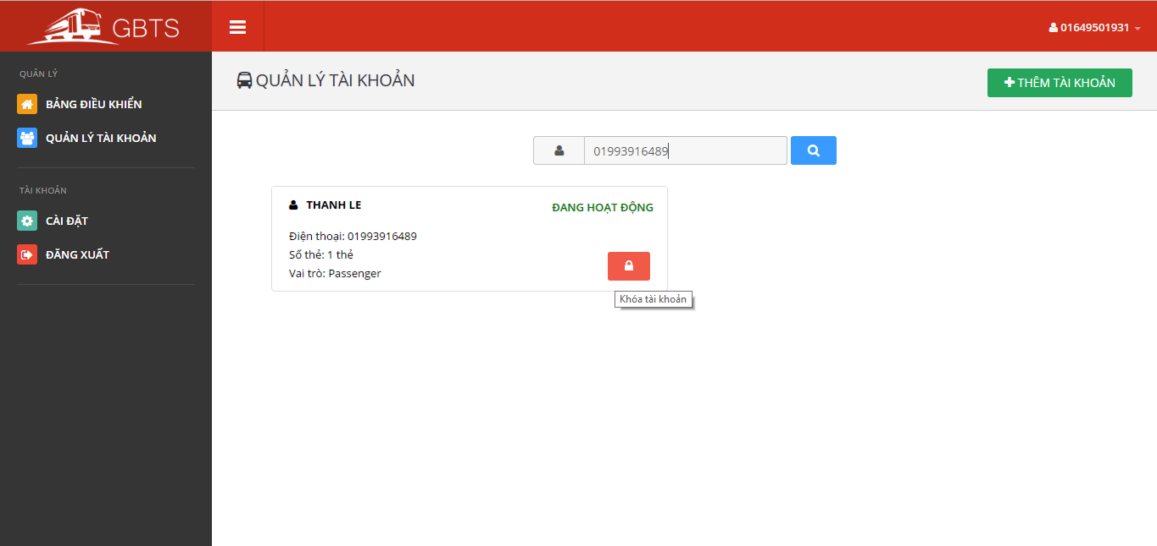

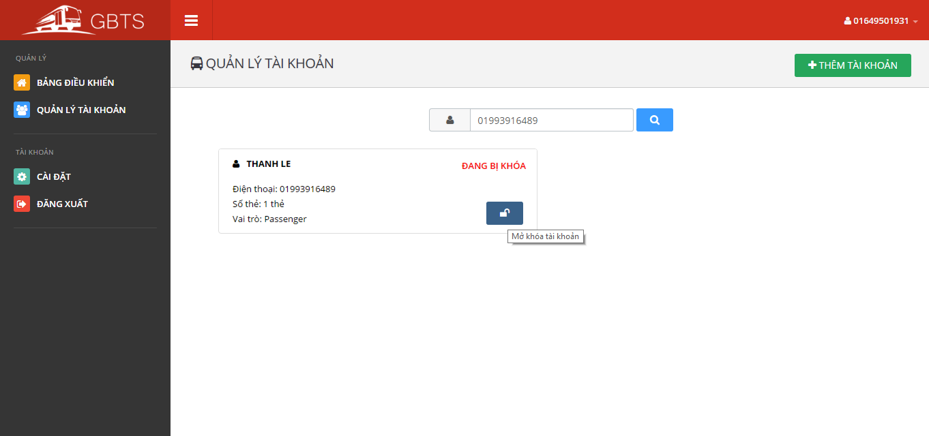

|  |  |
| --- | --- |
| Step | Description |
| 1 | Click “Quản lý tài khoản” button |
| 2 | Input a phone number |
| 3 | Click “Khóa tài khoản” or “Mở khóa tài khoản” button |

* + 1. <Staff> Publish scratch cards

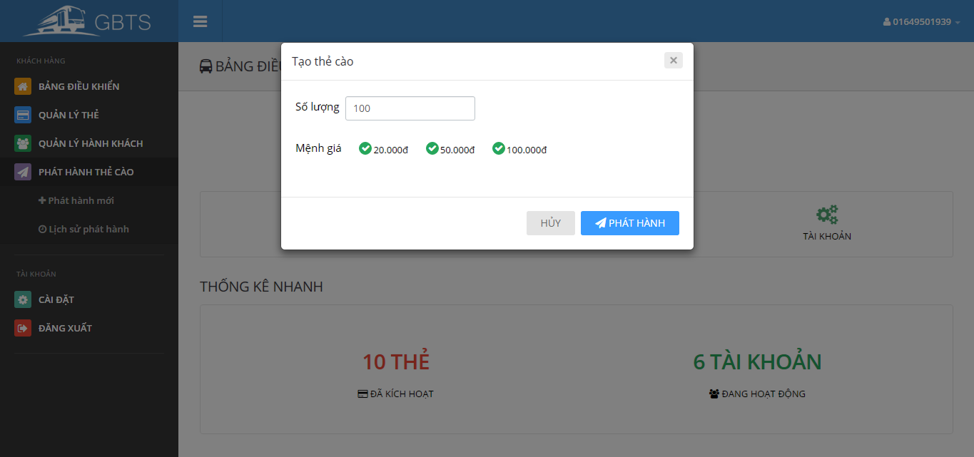

|  |  |
| --- | --- |
| Step | Description |
| 1 | Click “Phát hành thẻ cào” button |
| 2 | Click “Phát hành mới” button |
| 3 | Input all information |
| 4 | Click “Phát hành” button |

* + 1. <Staff> Search card

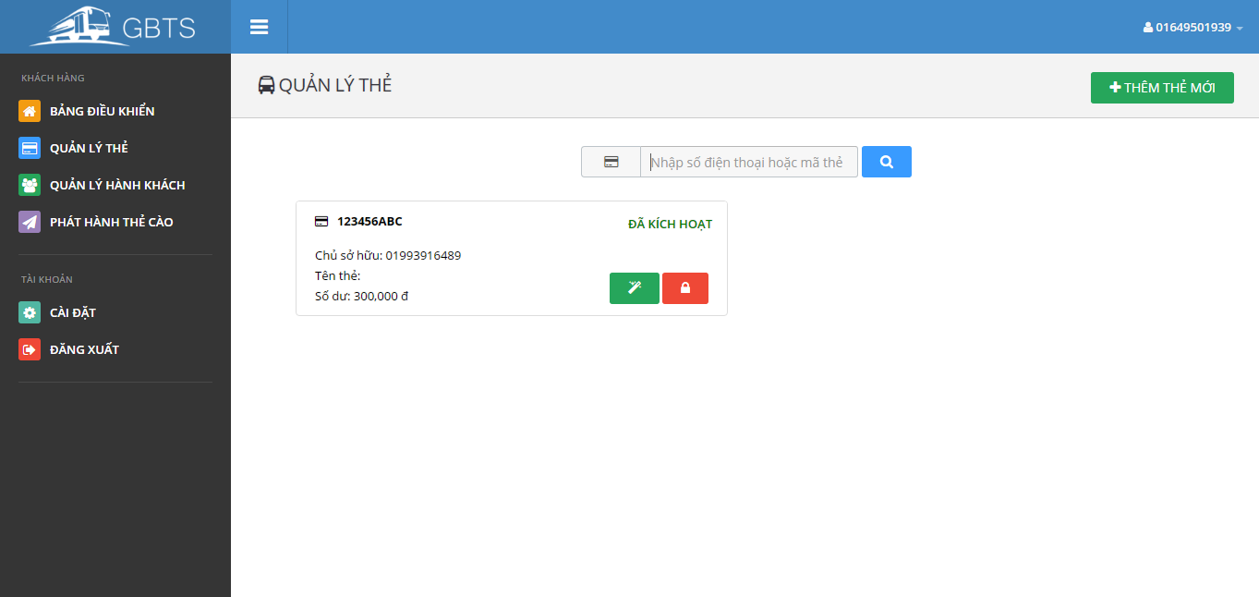

|  |  |
| --- | --- |
| Step | Description |
| 1 | Click “Quản lý thẻ” button |
| 2 | Input card ID |
| 4 | Click search button |

* + 1. <Staff> Add card



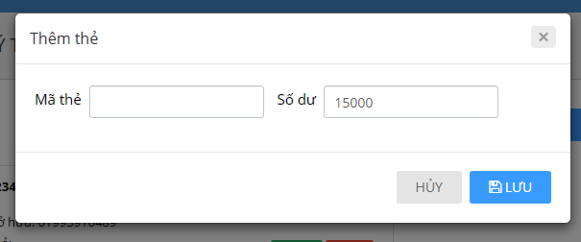

|  |  |
| --- | --- |
| Step | Description |
| 1 | Click “Quản lý thẻ” button |
| 2 | Click “Thêm thẻ mới” button |
| 3 | Tap new NFC card on the NFC reader or enter card ID by hand |
| 4 | Input initial balance |
| 5 | Click “Lưu” button |

* + 1. <Staff> Activate/Deactivate card

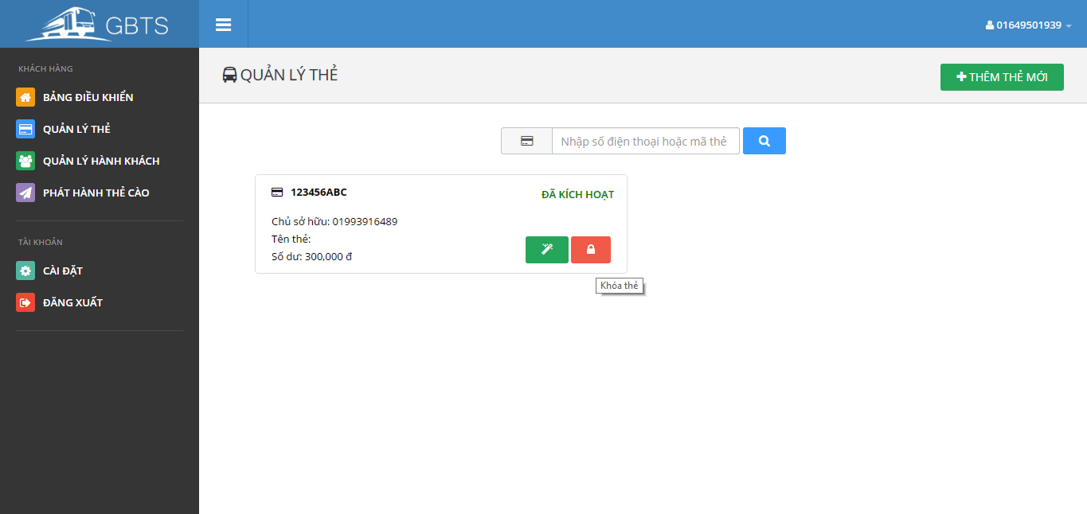

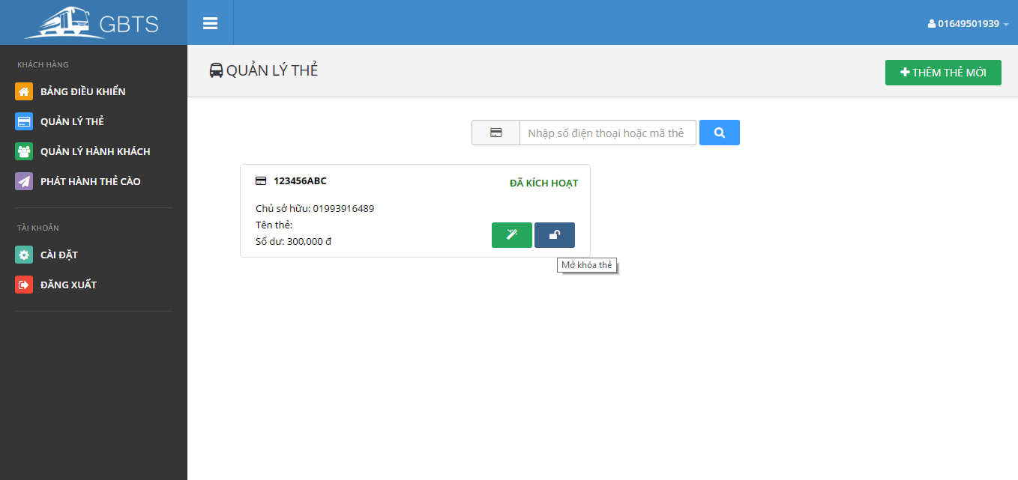

|  |  |
| --- | --- |
| Step | Description |
| 1 | Click “Quản lý thẻ” button |
| 2 | Input card ID or a phone number |
| 3 | Click “Khóa thẻ” button or “Mở khóa thẻ” button |

* + 1. <Staff> Search passenger

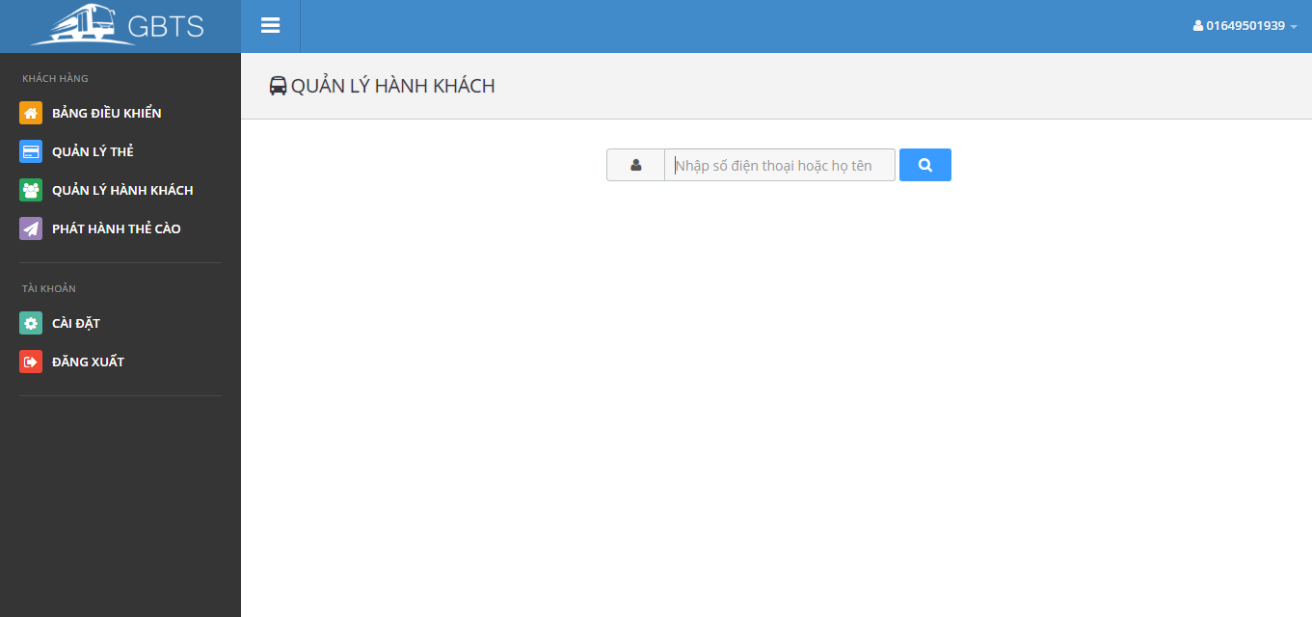

|  |  |
| --- | --- |
| Step | Description |
| 1 | Click “Quản lý hành khác” button |
| 2 | Input phone number or name |
| 3 | Click search button |

* + 1. <Manager> Add ticket type

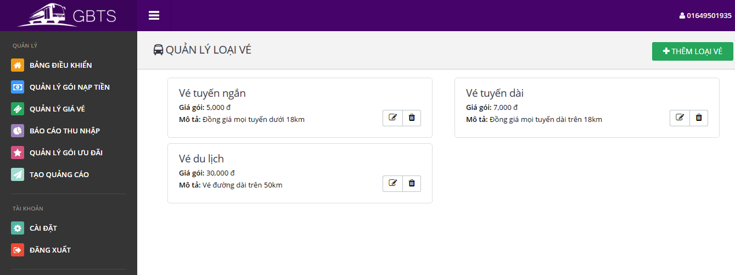

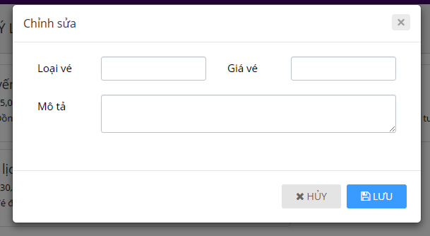

|  |  |
| --- | --- |
| Step | Description |
| 1 | Click “Quản lý giá vé” button |
| 2 | Input phone number or name |
| 3 | Click “Lưu” button |

* + 1. <Manager> Edit ticket type



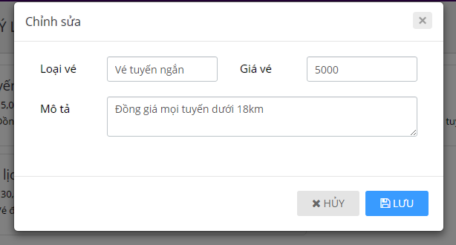

|  |  |
| --- | --- |
| Step | Description |
| 1 | Click “Quản lý giá vé” button |
| 2 | Click edit button on a ticket type |
| 3 | Click “Lưu” button |

* + 1. <Manager> Delete ticket type



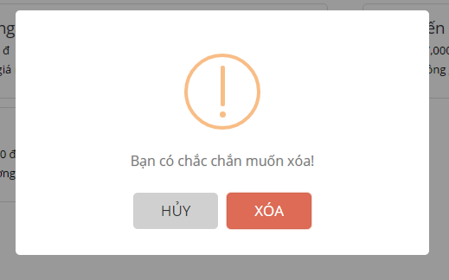

|  |  |
| --- | --- |
| Step | Description |
| 1 | Click “Quản lý giá vé” button |
| 2 | Click delete button on a ticket type |
| 3 | Confirm by clicking “Xóa” button |

* + 1. <Manager> Add credit plan

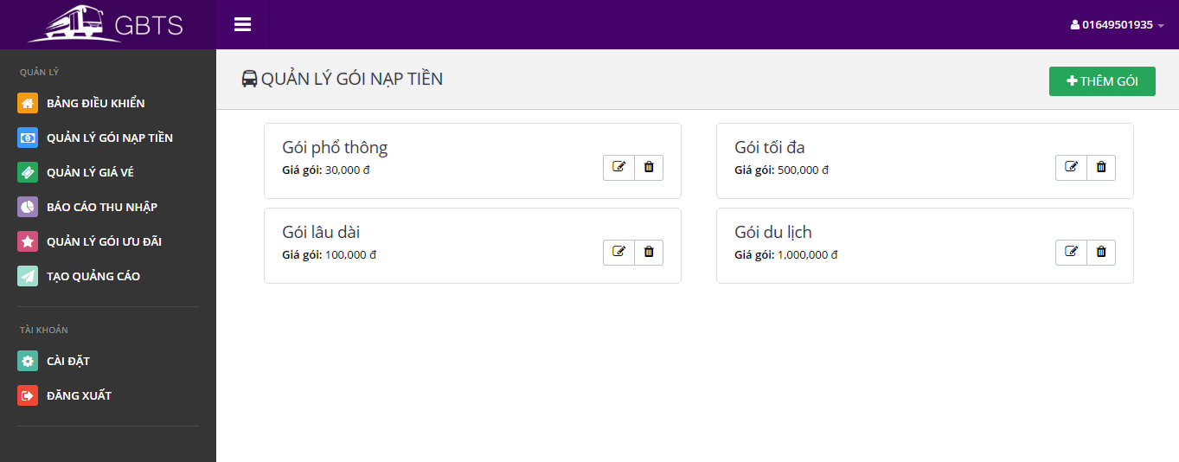

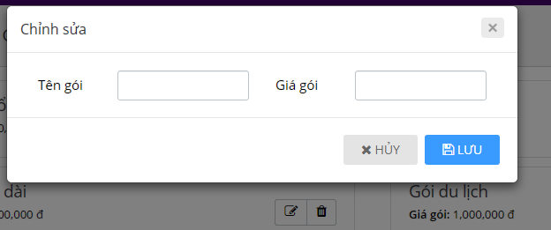

|  |  |
| --- | --- |
| Step | Description |
| 1 | Click “Quản lý gói nạp tiền” button |
| 2 | Click “Thêm gói” button |
| 3 | Input new credit plan information |
| 4 | Click “Lưu” button |

* + 1. <Manager> Edit credit plan



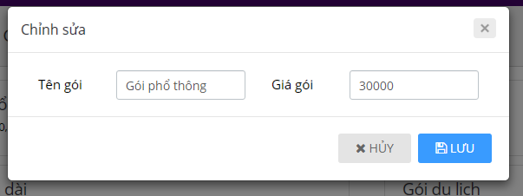

|  |  |
| --- | --- |
| Step | Description |
| 1 | Click “Quản lý gói nạp tiền” button |
| 2 | Click edit button on a credit plan |
| 3 | Edit credit plan information |
| 4 | Click “Lưu” button |

* + 1. <Manager> Delete credit plan



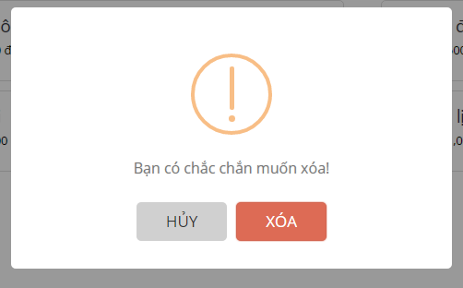

|  |  |
| --- | --- |
| Step | Description |
| 1 | Click “Quản lý gói nạp tiền” button |
| 2 | Click delete button on a credit plan |
| 3 | Confirm by clicking “Xóa” button |

* + 1. <Manager> Add subscription

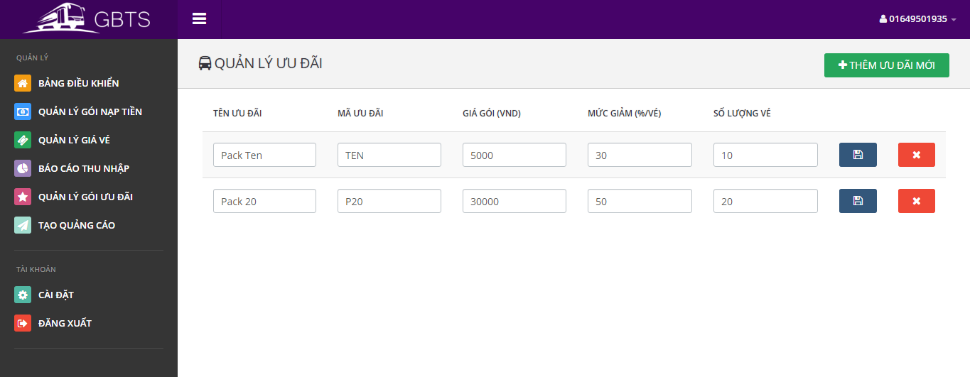

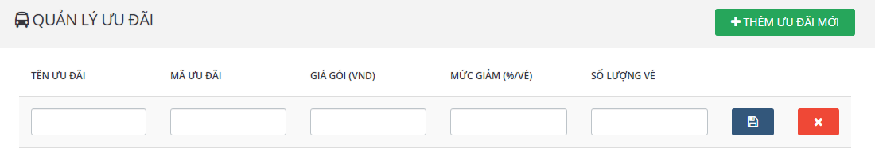

|  |  |
| --- | --- |
| Step | Description |
| 1 | Click “Quản lý gói ưu đãi” button |
| 2 | Click “Thêm ưu đãi mới” button |
| 3 | Enter new promotion package information |
| 4 | Click save button |

* + 1. <Manager> Edit subscription



|  |  |
| --- | --- |
| Step | Description |
| 1 | Click “Quản lý gói ưu đãi” button |
| 3 | Edit promotion package information |
| 4 | Click save button |

* + 1. <Manager> Delete subscription



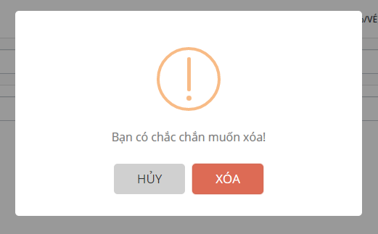

|  |  |
| --- | --- |
| Step | Description |
| 1 | Click “Quản lý gói ưu đãi” button |
| 3 | Click delete button on a promotion package |
| 4 | Confirm by click “Xóa” button |

* + 1. <Manager> Get income report

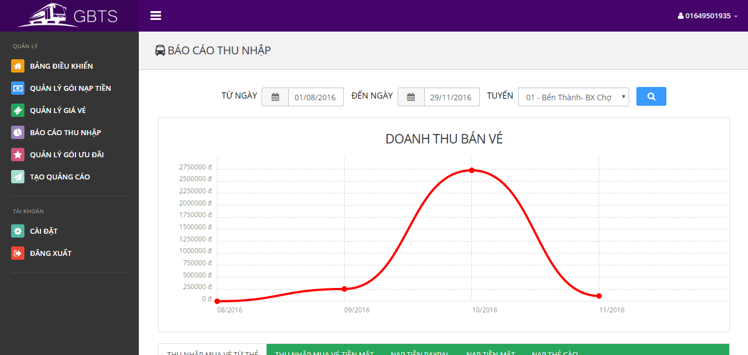

|  |  |
| --- | --- |
| Step | Description |
| 1 | Click “Báo cáo thu nhập” button |
| 3 | Input query information |
| 4 | Click search button |

* + 1. <Manager> Create promotion

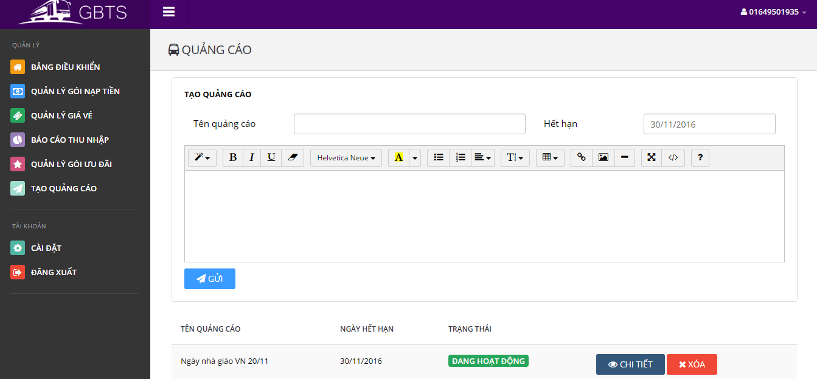

|  |  |
| --- | --- |
| Step | Description |
| 1 | Click “Tạo quảng cáo” button |
| 3 | Input new advertisement information |
| 4 | Click “Gửi” button |

### Mobile application

* + 1. <Passenger> View Login

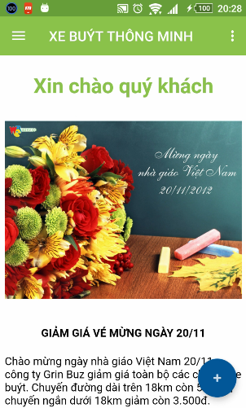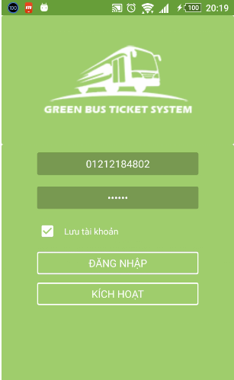

|  |  |
| --- | --- |
| Step | Description |
| 1 | Tab “ĐĂNG NHẬP” |
| 2 | Tap “KÍCH HOẠT “ |

* + 1. 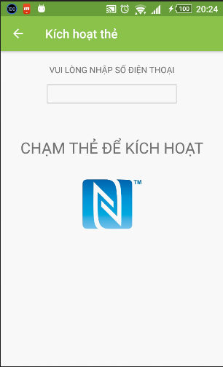<Passenger> View Active Card

|  |  |
| --- | --- |
| Step | Description |
| 1 | Input your phone number, tap and hold to Active Card |

#### <Passenger> Function Overview

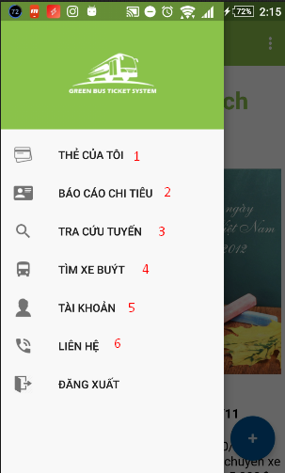

|  |  |
| --- | --- |
| Step | Description |
| 1 | Tap “THẺ CỦA TÔI”. |
| 2 | Tap “BÁO CÁO CHI TIÊU” |
| 3 | Tap “TRA CỨU TUYẾN” |
| 4 | Tap “TÌM XE BUÝT” |
| 5 | Tap “TÀI KHOẢN” |
| 6 | Tap “LIÊN HỆ “ |

#### <Passenger> THẺ CỦA TÔI

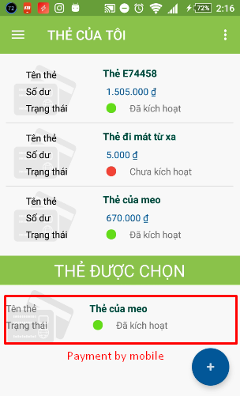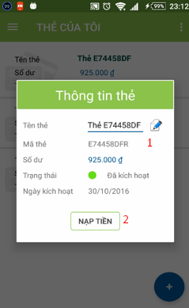

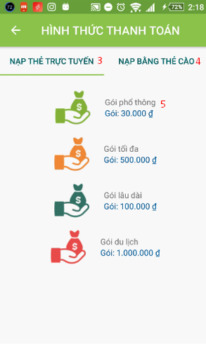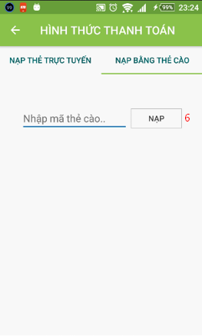

|  |  |
| --- | --- |
| Step | Description |
| 1 | Click one item of list card on fragment to view details and purchase. |
| 2 | Tap “ICON” to edit Name card. |
| 3 | Tap “NẠP THẺ TRỰC TUYẾN” purchase to recharge. |
| 4 | Tap “NẠP BẰNG THẺ CÀO”. |
| 5 | Click one item of list credit plan on fragment to recharge. |
| 6 | Tap “NẠP” to recharge. |

#### <Passenger> BÁO CÁO CHI TIÊU

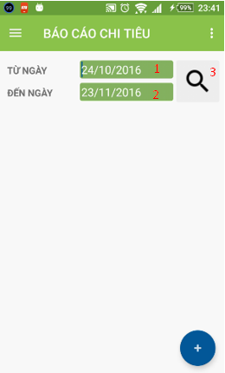

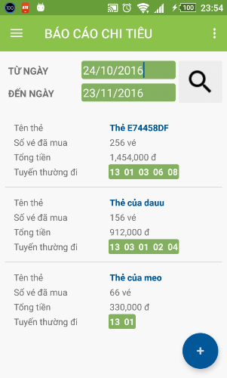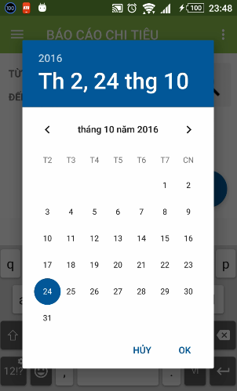

|  |  |
| --- | --- |
| Step | Description |
| 1 | Click “TỪ NGÀY” to choose date. |
| 2 | Click “ĐẾN NGÀY” to choose date. |
| 3 | Click “ICON SEARCH” to get report. |

#### <Passenger> TRA CỨU TUYẾN

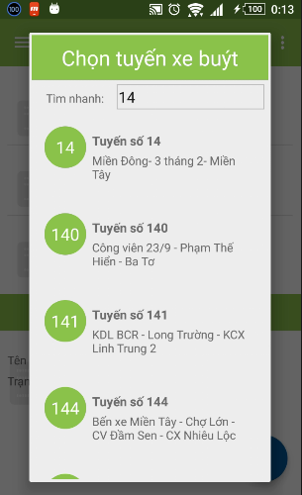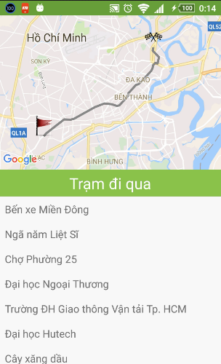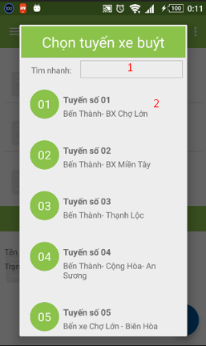

|  |  |
| --- | --- |
| Step | Description |
| 1 | Filler to fine bus routes |
| 2 | Click one item of list bus routes to find direction and bus routes. |

#### <Passenger> TÌM XE BUÝT

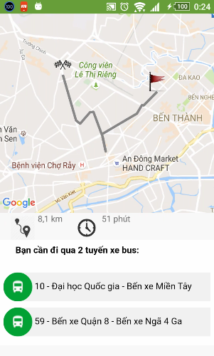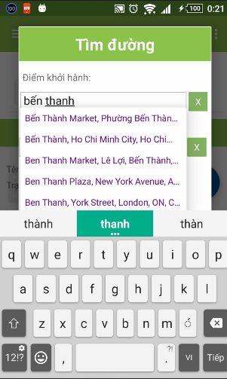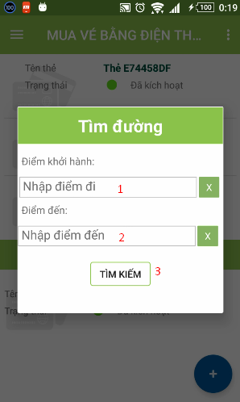

|  |  |
| --- | --- |
| Step | Description |
| 1 | Choose origin direction |
| 2 | Choose destination direction |
| 3 | Tap “TÌM KIẾM” to find bus routes |

#### <Passenger > TÀI KHOẢN

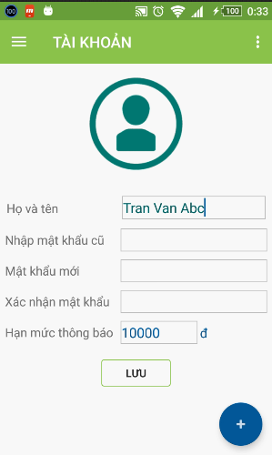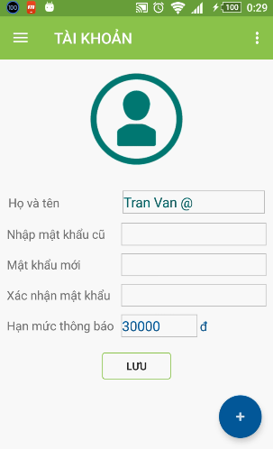

|  |  |
| --- | --- |
| Step | Description |
| 1 | Click “LƯU” to change profile. |

### Emulator application

#### Verify ticket

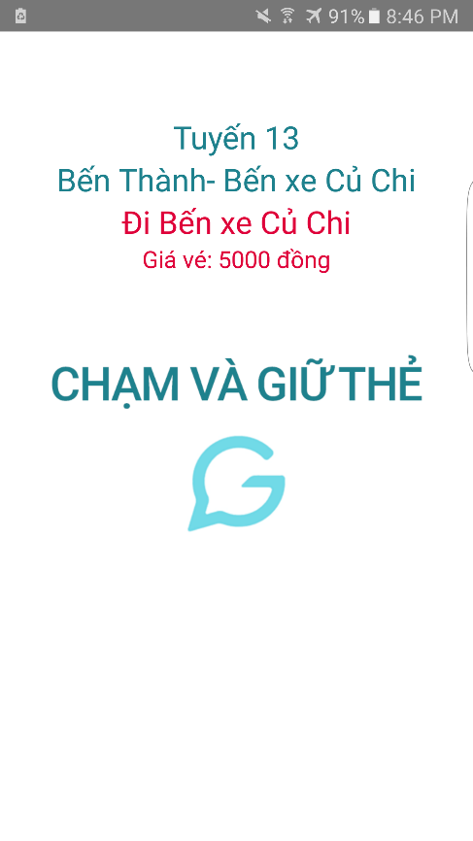

|  |  |
| --- | --- |
| Step | Description |
| 1 | Open Bus Emulator application |
| 2 | Tap and hold NFC card or NFC-enabled phone on the NFC reader |

#### Configure emulator

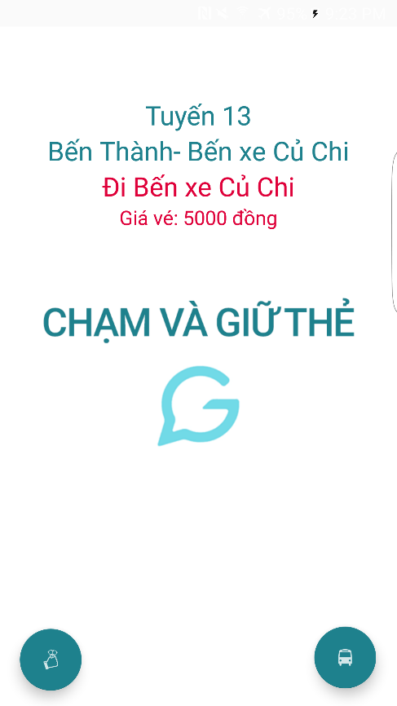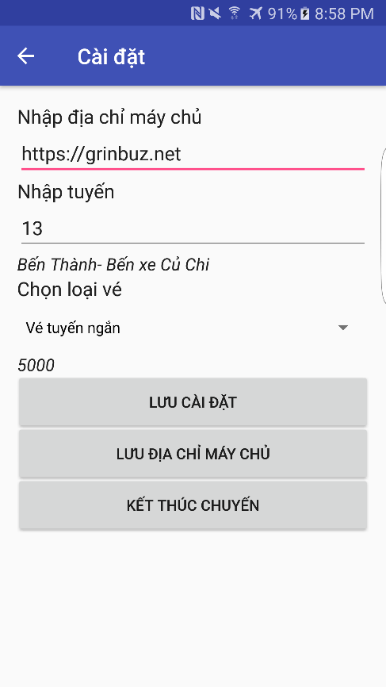

|  |  |
| --- | --- |
| Step | Description |
| 1 | Open Bus Emulator application |
| 2 | Tap driver’s NFC card on the NFC reader |
| 3 | Press on Bus floating button |
| 4 | Input a bus code and select a ticket type |
| 5 | Press “Lưu cài đặt” button |

#### C:\Users\Duc\AppData\Local\Microsoft\Windows\Temporary Internet Files\Content.Word\Screenshot_20161120-212352.pngSell cash ticket

|  |  |
| --- | --- |
| Step | Description |
| 1 | Open Bus Emulator application |
| 2 | Tap driver’s NFC card on the NFC reader |
| 3 | Press on Cash floating button |

#### Publish card

|  |  |
| --- | --- |
| Step | Description |
| 1 | Open Card Publisher application |
| 2 | Open publish card panel on the web application |
| 3 | Tap and hold new NFC card on the NFC reader |

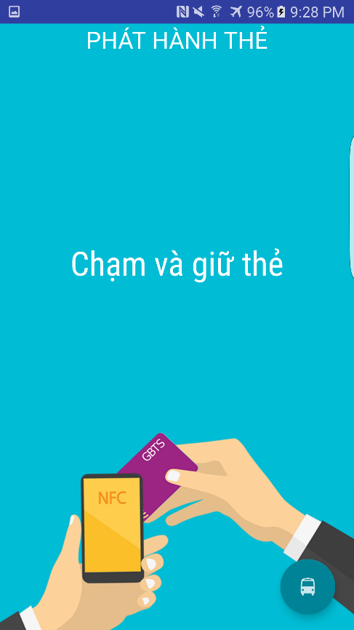

#### C:\Users\Duc\AppData\Local\Microsoft\Windows\Temporary Internet Files\Content.Word\Screenshot_20161120-212801.pngPublish card (Immediately publish a card without using the web application)

|  |  |
| --- | --- |
| Step | Description |
| 1 | Open Card Publisher application |
| 2 | Tap and hold new NFC card on the NFC reader |